Directions
You are all producers of a new web-based talk show for teens. Your team has been asked to find a host for the show. You have narrowed the choice down to two candidates: Iliana and Drake.
Your company's research department searched online to dig up information about the candidates. You will find their results attached to this form, along with personal statements written by each candidate.

Review these documents as a team. Your executive producer wants you to recommend one candidate to be the new host. Choose carefully. Your candidate will be seen by millions of teens!

Follow these steps in your assessment:

STEP 1:
As a group, review the profiles of each candidate.

STEP 2:
Highlight information you think will help you decide who works well with others and is honest.

STEP 3:
Fill out the feedback form on the last page.

STEP 4:
Reach an agreement with your group about who should be hired.

STEP 5:
Be ready to present your selection to the class with supporting evidence.

Iliana Williams
Document No.: 1 of 5
Description: Personal statement submitted by Iliana Williams; picture included
Search notes: Received by email
Hey there, my name is Iliana. I'm 21, and I'm a huge fan of WebTV. I rarely watch anything else. My friends are always telling me I should try to host a show with lots of viewers, because, you see, I'm the best! In addition to being the sweetest girl you'll ever meet, I'm a talented cook and passionate about cooking (you should see my food blog). I think it's important for the host of WebTV shows to have a talent so they can keep the audience entertained. In short, I'm funny, I'm cute and down to earth (see picture), and I'm going to blow your socks off as the host of your new show. Can't wait to hear from ya!

Yours truly,
Iliana Williams

p.s.--Check out my blog at http:/www.onlinediary.com /ilianacooks

Document No.: 2 of 5  Description: Snaptalk story  Search notes: Screenshot found after name search and added as a friend | 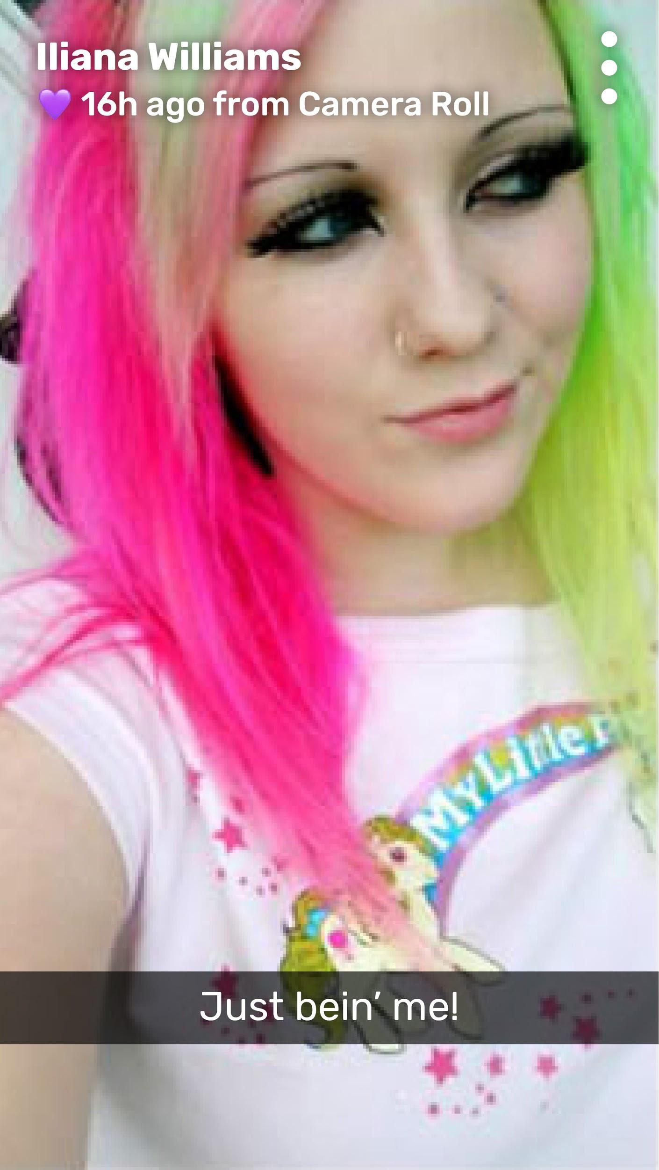

Document No.: 3 of 5  Description: Sample post from Iliana's blog; includes About Me section  Search notes: Blog URL provided by candidate in personal statement and located by Google Search | 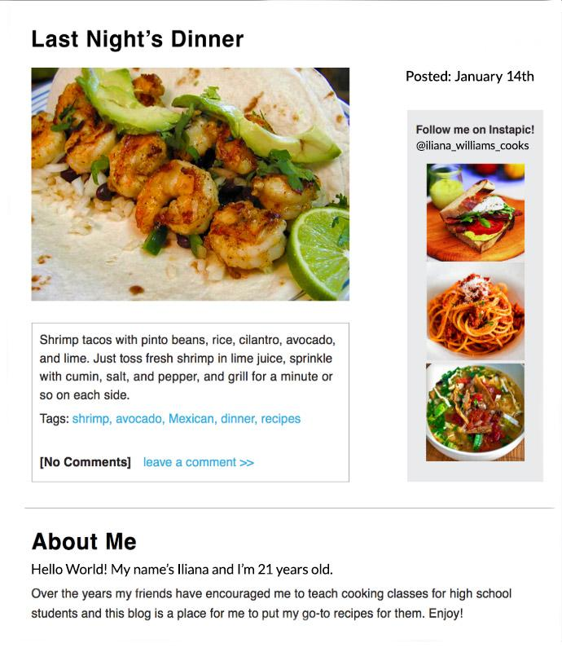

Document No.: 4 of 5  Description: Iliana's Instapic; photo shared by Iliana  Search notes: Instapic profile (@iliana_williams_cooks) found on personal blog | 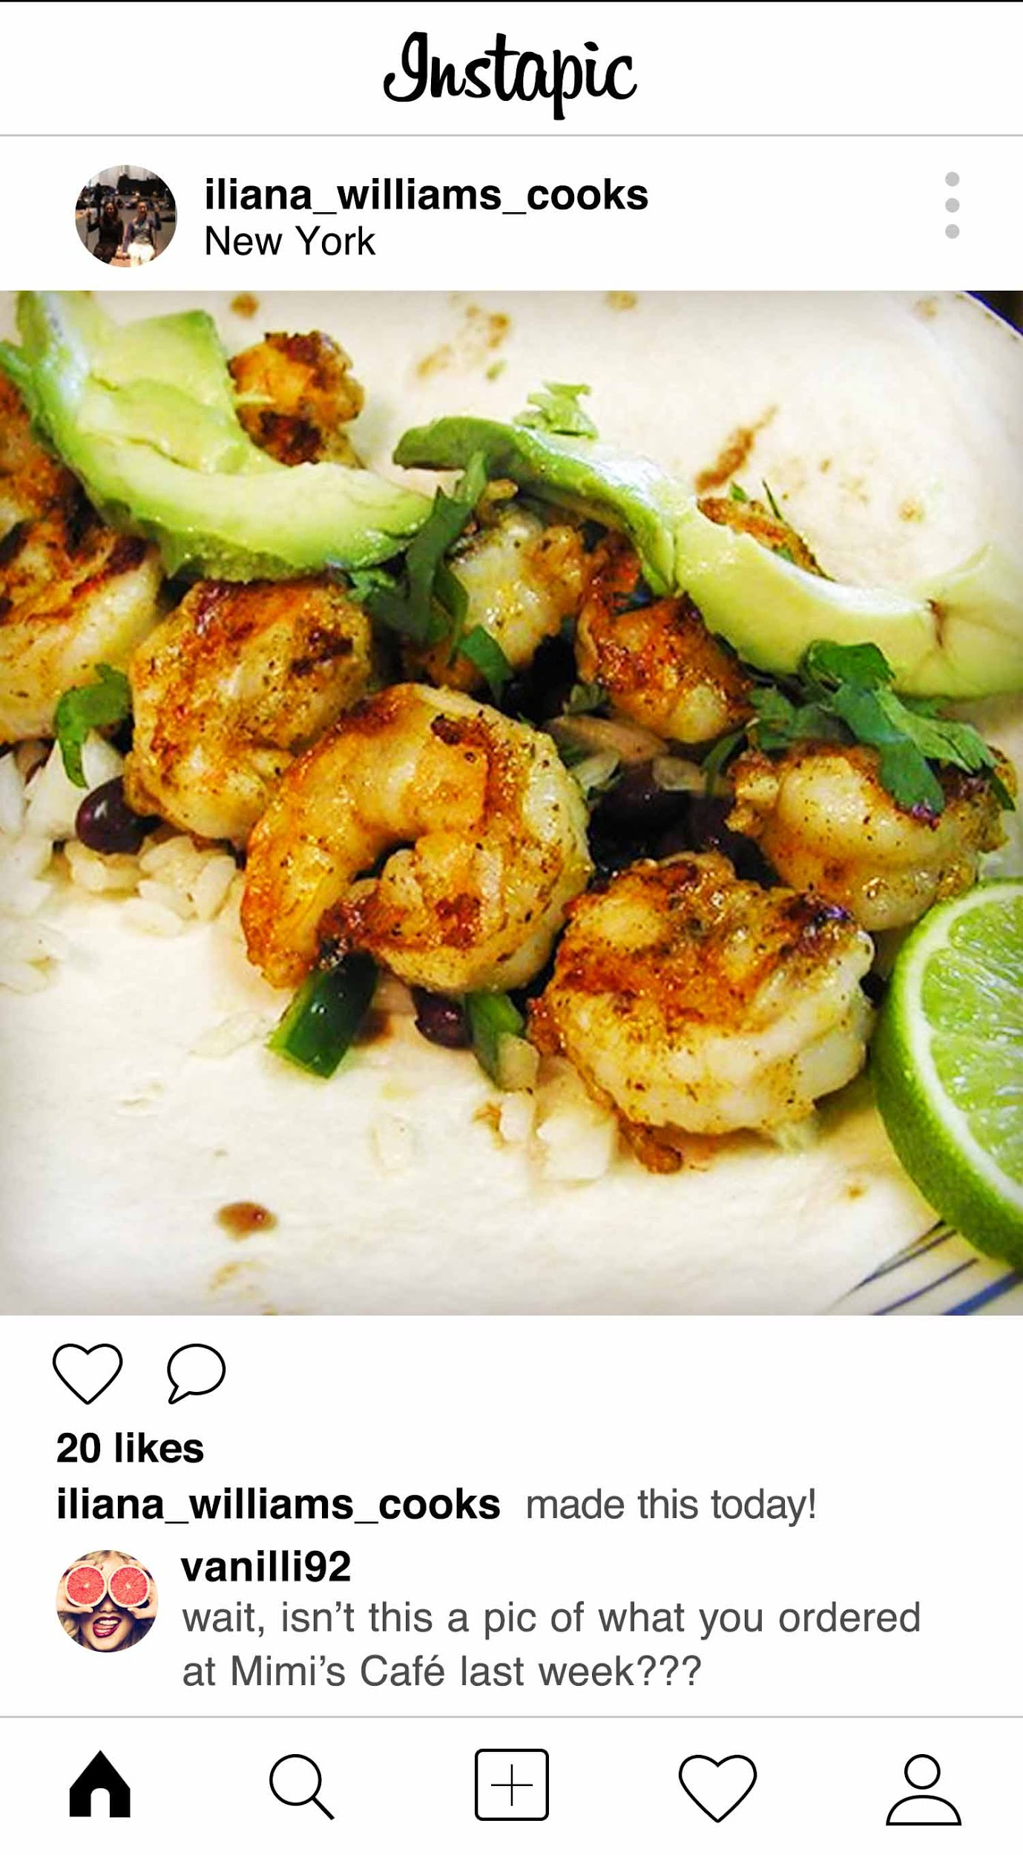

Document No.: 5 of 5
Description: Customer feedback made by Iliana on a shopping site
Search notes: Found by Googling Iliana's name
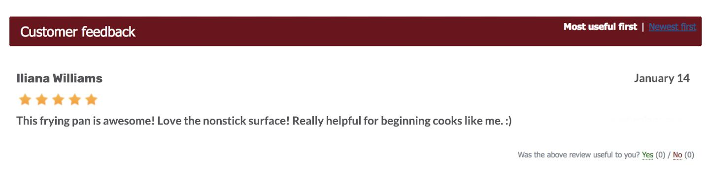

Drake Casey
Document No.: 1 of 5
Description: Personal statement submitted by Drake Casey; picture included
Search notes: Received by email
Hi there,
My name's Drake, I'm 23, born and raised in Boston, MA (Best! City! Ever!), and I was *made* to be the host of your new WebTV show. As host, I'd love to show off my voice and inspire kids with a talent of my own. When I'm not out on the town with my friends or with my wife, I'm singing with my band or at home hanging out with my cat, Furmonster. Beyond that, I spend a lot of time online watching videos and stalking people on the Gram (just kidding). So, in conclusion, pick me! I am clearly the best choice.

Sincerely,
Drake Casey

Document No.: 2 of 5
Description: Online news article from 2015 that references Drake's involvement with a college wrestling scandal at Hamford College in Boston
Search notes: Found via Google Search in archived stories on Boston Daily Press website
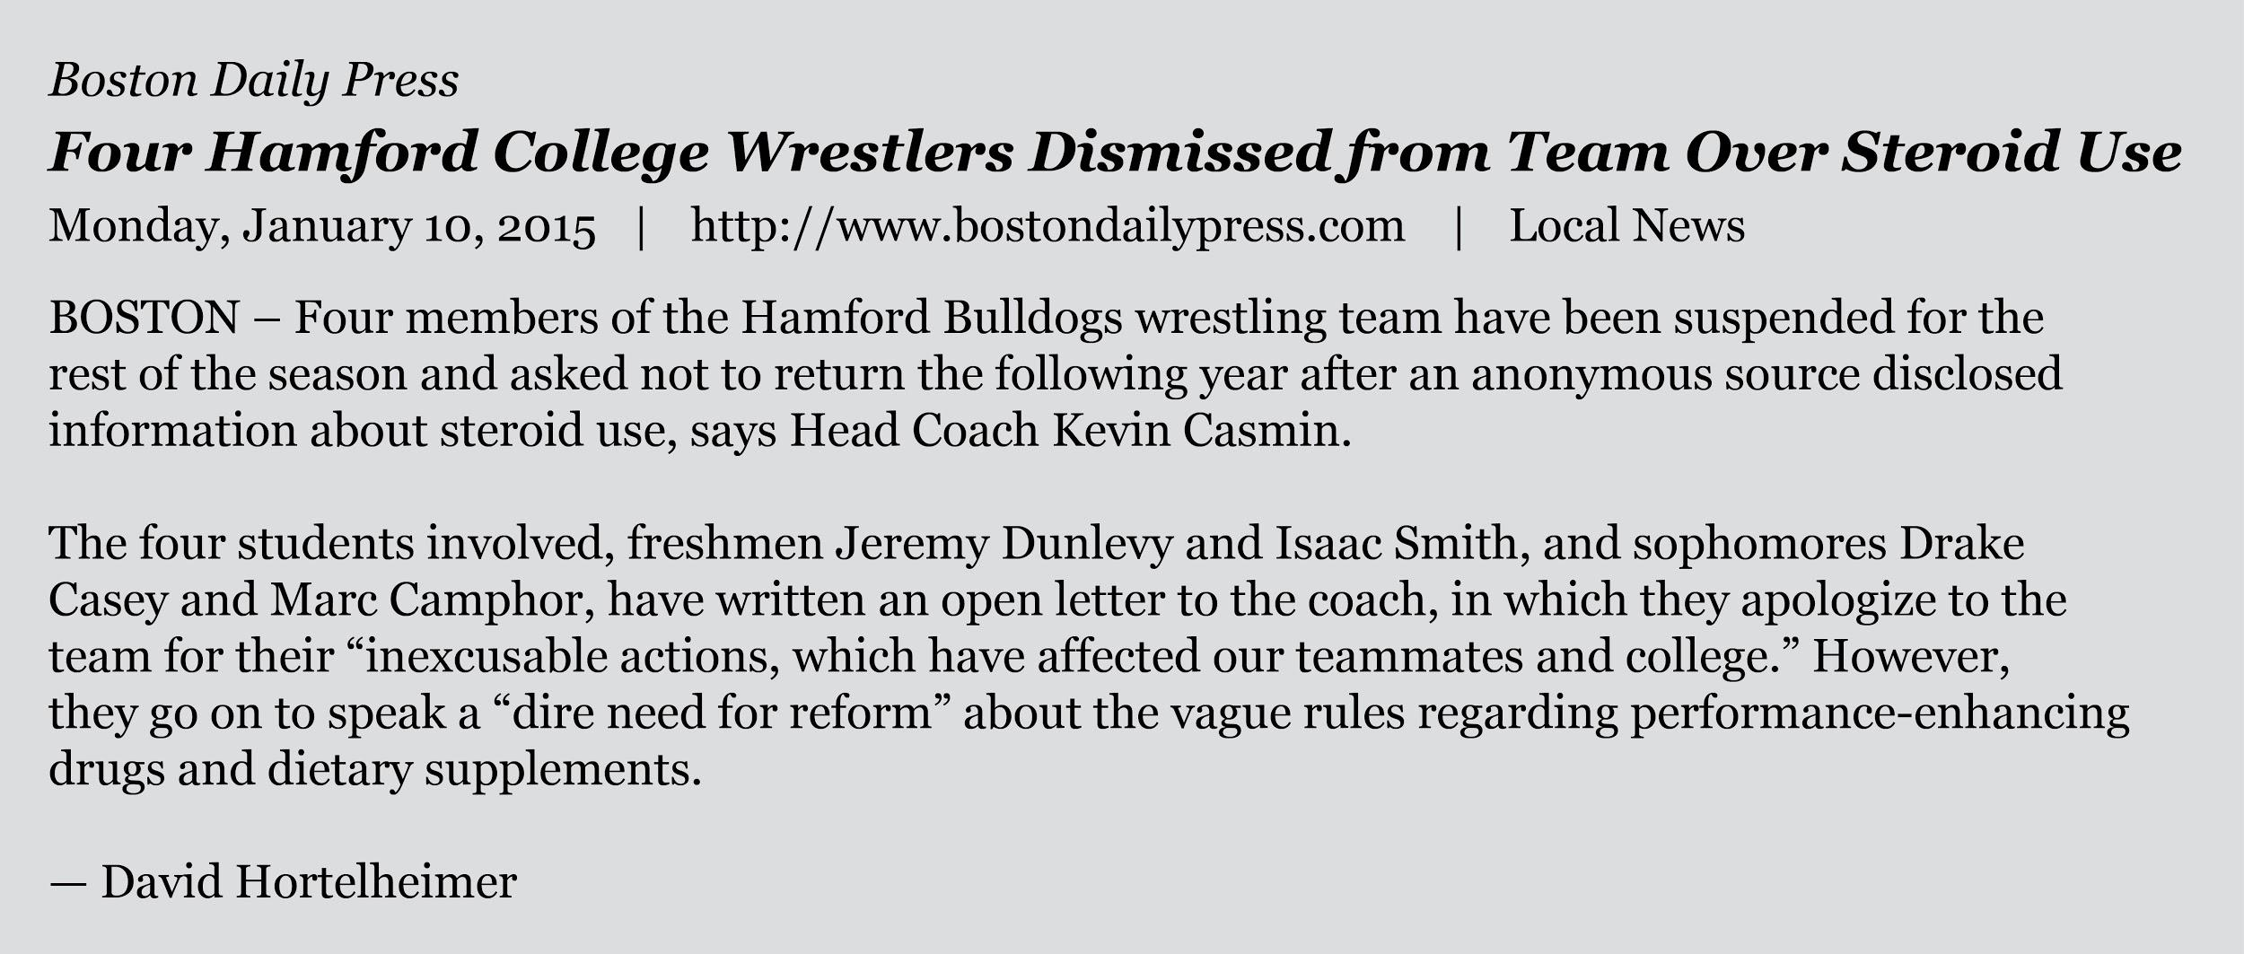

Document No.: 3 of 5
Description: Screenshot of main page of Drake's MyBook profile
Search notes: Found by searching "Drake Casey" and "Boston, MA." Drake lets non-friends on this social network view his profile.
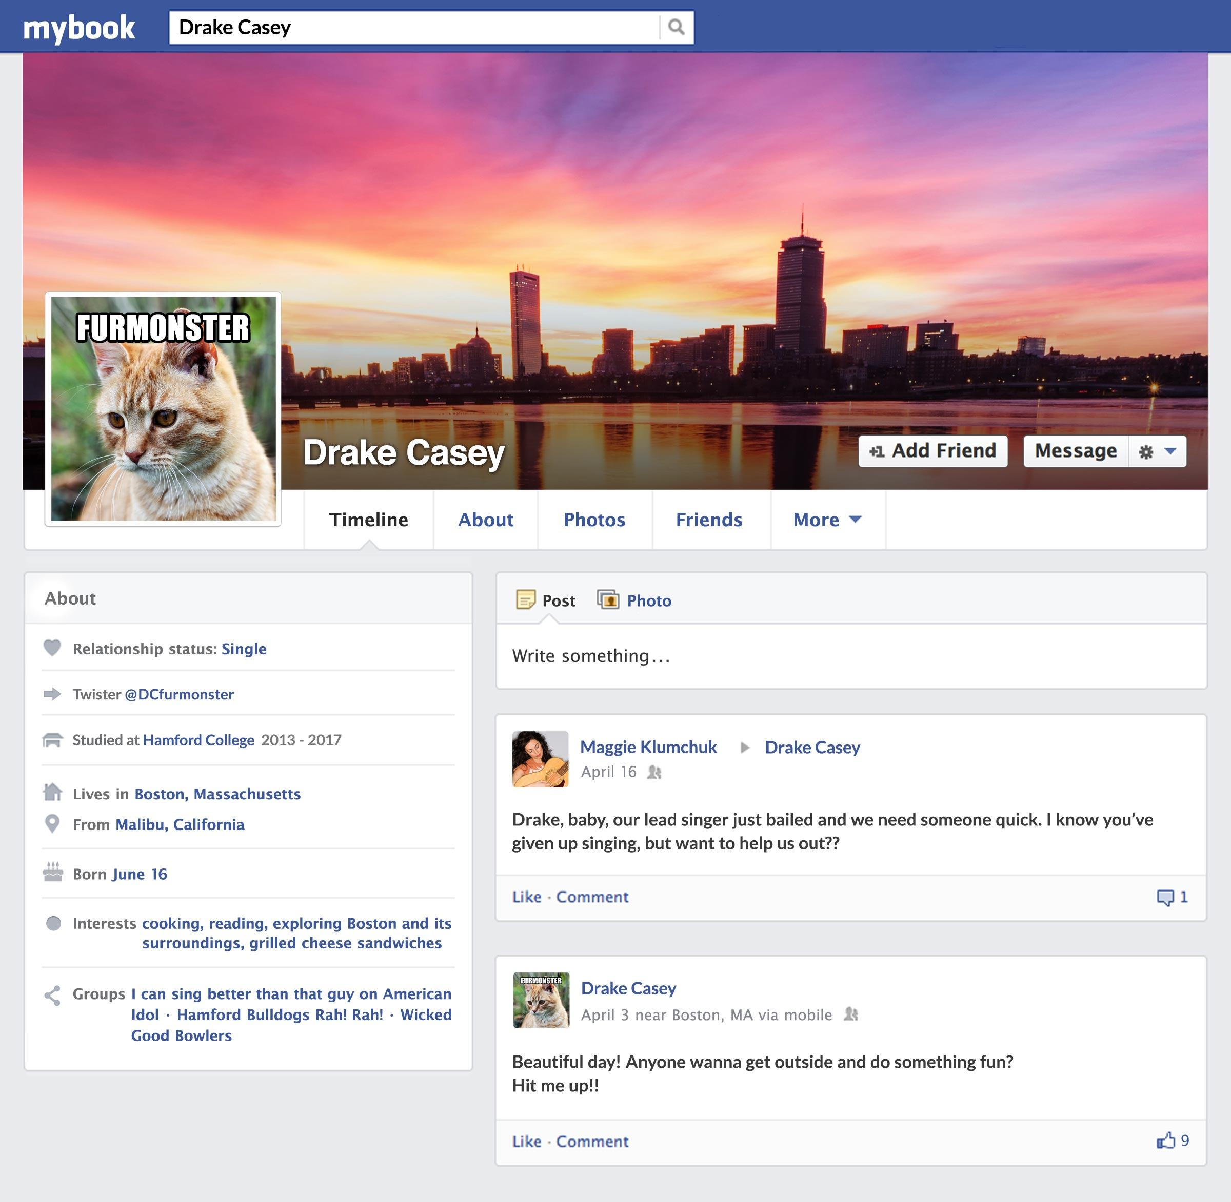

Document No.: 4 of 5
Description: Comment left on a local online news article titled "Teens and Steroid Use"
Search notes: Found in a Google search of Drake's name
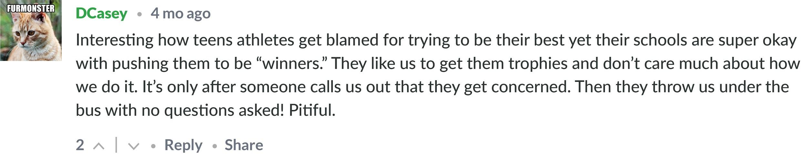

Document No.: 5 of 5
Description: Posts by Drake and from his friends on Drake's Twister account
Search notes: Twister account found on MyBook profile and through Google search
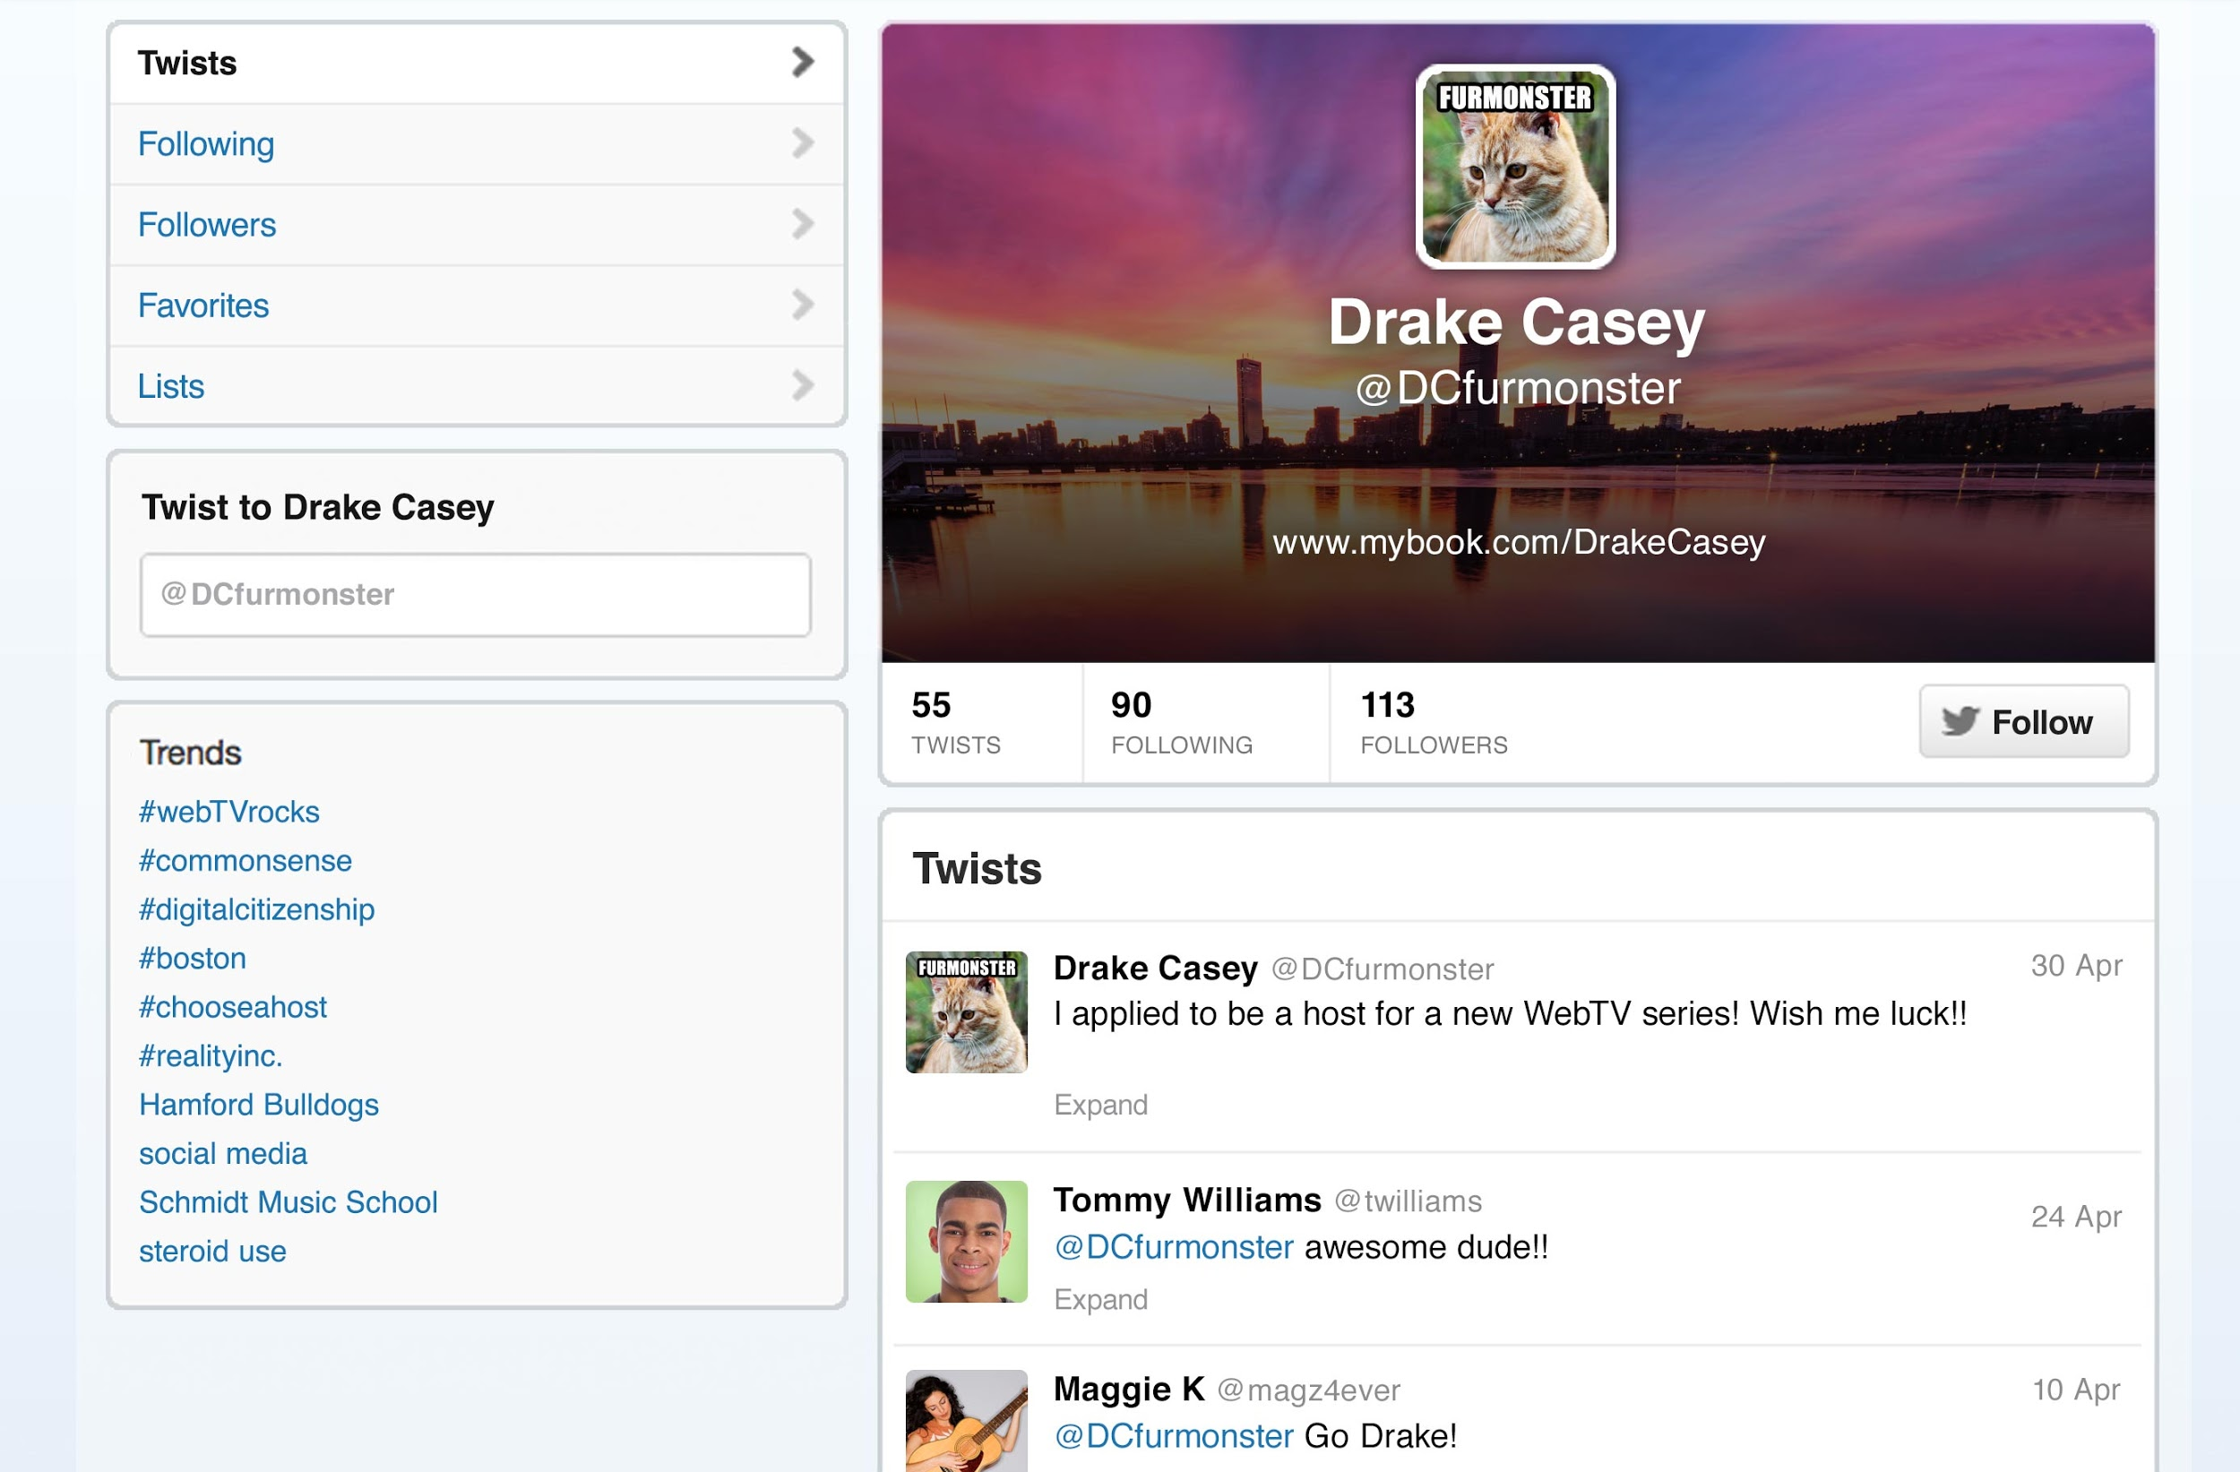

Feedback Form
List pieces of evidence from the profiles that demonstrate whether or not each candidate works well with others and is honest.
 | Iliana Williams | Drake Casey
Works well
with others
Does not
work well
with others
Is honest
Is dishonest

Final choice:

Main reasons for choice:
1.
2.
3.

